

Foundations of Programming

Assignment No.: 18
PROBLEM STATEMENT: Write a C program that accepts a string from the user and performs the following string operations: i) Calculate length of string ii) String reversal iii) Equality check of two strings iv) Check palindrome v) Check substring.

OBJECTIVE:

- To understand basic string operations in C.
- To learn how to manipulate strings using loops and functions.
- To perform comparison, reversal, and substring checking.
- To check whether a string is a palindrome.

THEORY:
In C programming, a string is a sequence of characters terminated by a null character ('\0'). Strings are commonly stored in character arrays. Various operations can be performed on strings such as calculating their length, reversing the characters, comparing two strings, checking whether a string is a palindrome, and finding a substring within another string. These operations can be implemented using loops and conditional statements or by using standard library functions from the string.h header file.

ALGORITHM:
Step1: START
Step2: Declare strings: str1, str2, rev
Step3: Input str1 (main string)
Step4: Input str2 (second string for compare)

Length calculation:
Step5: Initialize length = 0
Step6: Repeat until str[1] != ‘\0’
Step7: Display length

String Reversal:
Step8: Initialize j = length – 1
Step9: For each character in str 1
Step10: Add ‘\0’ at end
Step11: Display reverse string

Palindrome Check:
Step12: Compare str1 and rev
Step13: If equal Print “Palindrome”
Step14: Else Print “Not Palindrome”

Equality Check:
Step15: Compare str1 and str2
Step16: If equal Print “String are equal”
Step17: Else Print “String are not equal”

Substring check:
Step18: Check if str2 exist inside str1
Step19: If found Print “Substring found”
Step20: Else Print “Substring not found”
Step21: STOP

FLOWCHART:
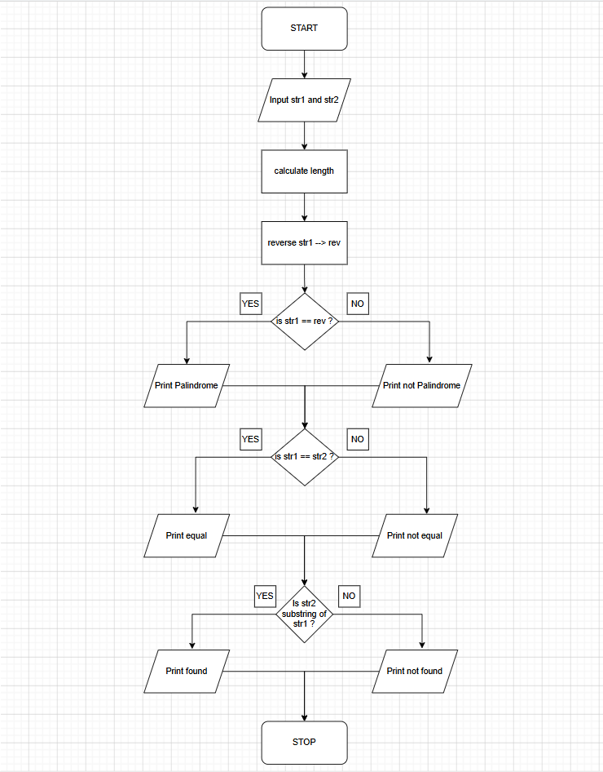

PLATFORM: C Compiler
CODE:
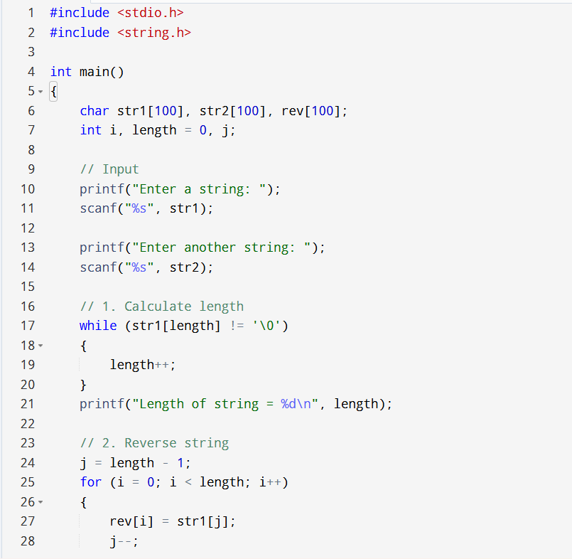
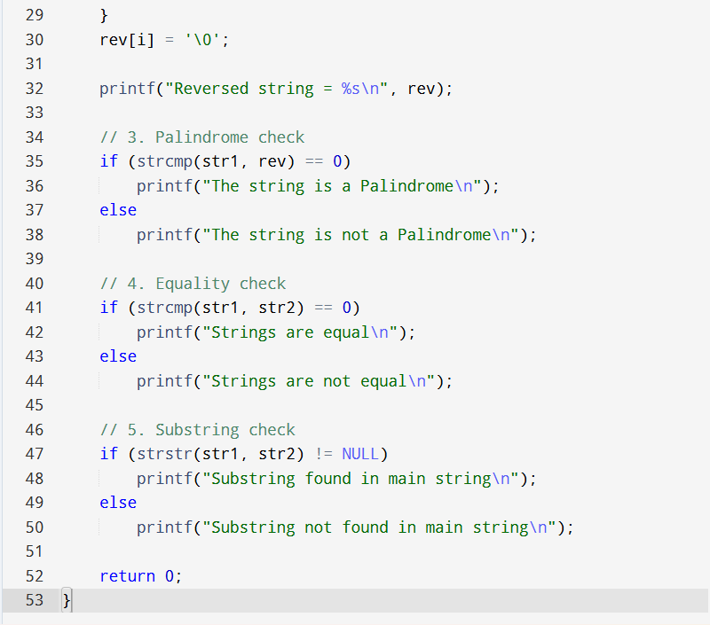

INPUT: A string and another string for comparison and substring checking.
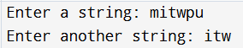

OUTPUT: Displays string length, reversed string, equality result, palindrome result, and substring check result.
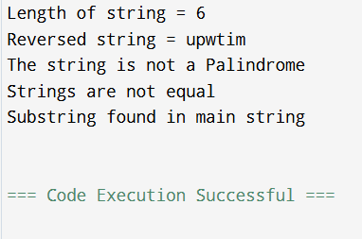

SAMPLE INPUT:

Enter a string: madam
Enter another string for equality check: mad
SAMPLE OUTPUT:
Length of string = 5
Reversed string = madam
The string is a Palindrome
Strings are not equal
Substring found in main string

CONCLUSION: Thus, the C program successfully performs different string operations such as length calculation, reversal, equality check, palindrome check, and substring detection.

FAQs:
- What is a string in C programming?
- Which header file is required for string functions?
- What function is used to find the length of a string?
- What is a palindrome string?
- Which function is used to check a substring in C?

